Venn Diagram
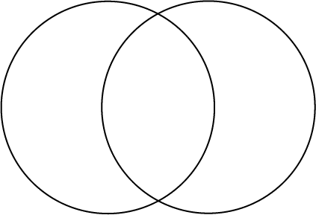

Consider what the similarities and differences are between both images.

Also think about how their lives would differ.

