WHO WAS DYLAN THOMAS? LISTENING AND REMEMBERING
Using what you have heard in the lesson and anything you yourself know about him, complete this sheet with ten facts about Dylan Thomas. Aim to write at least 5 good points yourself then, if you need to, you may check with a friend for further points and share your knowledge. Your points must be written clearly and accurately, but they can be short or long as you wish.

DYLAN THOMAS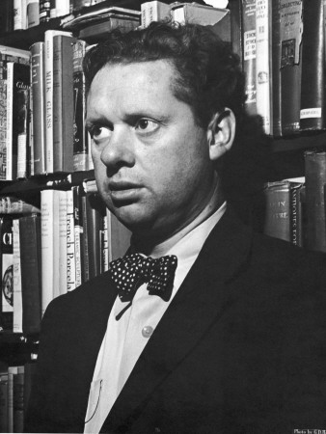S

