# Text to Self

|  |  |
| --- | --- |
| A Visit to Grandpa’s by Dylan Thomas | |
| When I read: | It reminded me of: |

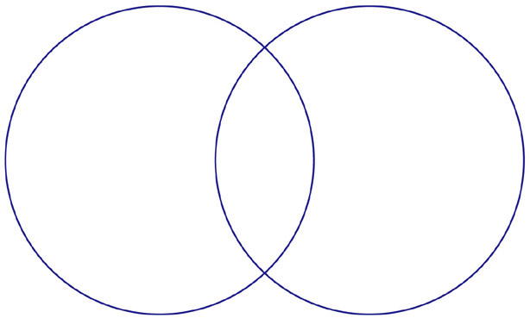

**A Visit to Grandpa’s**

____________________

# Text to Text

The text says…

This reminds me of…

# Text to World

