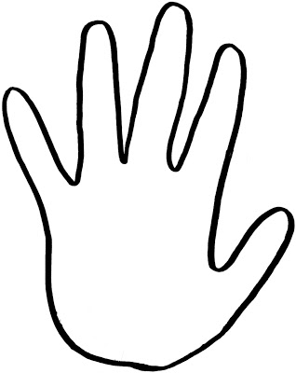

**Where?**

**Who?**

**How?**

**Why?**

**When?**

**What?**